Email Spam & Phishing Detection Multi‑Agent System Report

Coursework: CN7050 Intelligent Systems

Student Name: ____________________
Student ID: ______________________
Submission Date: __________________

Table of Contents

1. Application and Workflow Selection
1.1 Introduction and Motivation
1.2 Workflow of the Intelligent System
1.3 Objectives of the Intelligent System
1.4 Expected Impact

2. Selection of AI Technologies
2.1 Identification of Similar Systems
2.2 Innovative and Original Approach
2.3 Chosen AI Methods, Technologies and Services

3. Simulations and Development Setup
3.1 Simulation Environment and Setup Parameters
3.2 Agent-wise Task Distribution, Functionality and Datasets
3.3 Encoding and Data Processing Prior to Simulation

4. Use Case Explanation with Evidence
4.1 Step-by-Step Workflow Execution
4.2 Developed User Interface and External Interaction

5. Conclusions and References
5.1 Conclusions
5.2 References

1. Application and Workflow Selection

1.1 Introduction and Motivation
Email is one of the most pervasive communication mediums in modern society, yet it remains the dominant entry point for cyberattacks including phishing, fraudulent scams, malware distribution, credential harvesting, and mass spam dissemination. Adversaries routinely exploit human behavior and cognitive vulnerabilities to persuade users into clicking malicious links, disclosing sensitive information, or downloading harmful attachments.
Conventional rule-based filtering systems—although once reliable—are no longer sufficient, as attackers continuously refine email composition, linguistic patterns, and structural obfuscation techniques to evade signature-driven defenses. This growing sophistication highlights the necessity for a more adaptive, intelligent, and automated approach capable of identifying deceptive email content using pattern recognition rather than fixed manual rules.
This project introduces a comprehensive Email Spam and Phishing Detection System developed through a modular multi-agent architecture. The system ingests raw textual email data from two CSV sources (one containing legitimate communications and the other containing spam/phishing messages), performs advanced natural-language preprocessing, converts the text into TF-IDF feature representations, trains a supervised machine-learning classifier, and evaluates its performance using robust statistical indicators. A dedicated inference agent further enables real-time testing and simulation using new email samples.
The multi-agent structure reflects the design principles of modern intelligent systems, promoting extensibility, maintainability, and clear separation of responsibilities. For example, the classification component can be seamlessly upgraded from Logistic Regression to a transformer-based architecture (such as BERT), and the ingestion pipeline can be extended to support multi-class threat categorization without disrupting the rest of the system.

1.2 Workflow of the Intelligent System
The operational workflow of the Email Spam and Phishing Detection System is organized as a clearly defined sequence that aligns with AI engineering best practice and the CN7050 coursework requirements. A central Coordinator Agent orchestrates the pipeline, invoking each specialized agent in turn to ensure that processing steps occur in a controlled and reproducible order.
The end-to-end workflow is structured as follows:
- Dataset Upload (CSV Input) – The system expects two CSV files: one containing spam or phishing emails and another containing legitimate (ham) messages. These files are provided by the user via the notebook interface.
- Data Ingestion – The DataIngestionAgent loads both CSVs, verifies the presence of the required text column, removes records with missing content, assigns class labels (e.g., “spam” and “legit”), merges them into a single unified dataset and applies shuffling to avoid ordering bias.
- Text Preprocessing – The Preprocessing Agent standardizes the raw email text by converting it to lowercase, stripping URLs and HTML tags, removing symbols and numbers, and compressing redundant whitespace, producing a clean clean text field suitable for downstream modelling.
- Feature Engineering (TF-IDF Representation) – The FeatureEngineeringAgent transforms the cleaned text into high-dimensional TF-IDF feature vectors, capturing token importance and frequency patterns across the corpus while maintaining a sparse, memory-efficient representation.
- Model Training – The ModelTrainingAgent trains a Logistic Regression classifier using an 80/20 stratified train–test split, enabling the model to learn decision boundaries between spam and legitimate emails based on the TF-IDF features.
- Model Evaluation – The Evaluation Agent assesses performance on the held-out test set, producing metrics such as accuracy, precision, recall, F1-score, confusion matrices (raw and normalized) and summary statistics describing class-wise behavior.
- Inference and Simulation – The InferenceAgent exposes the trained pipeline for practical use, allowing new, unseen email examples to be classified and thereby simulating real-world operational behavior.
Together, these agents form a coherent, modular workflow that delivers accurate email classification while preserving clarity, separation of concerns and ease of extension.
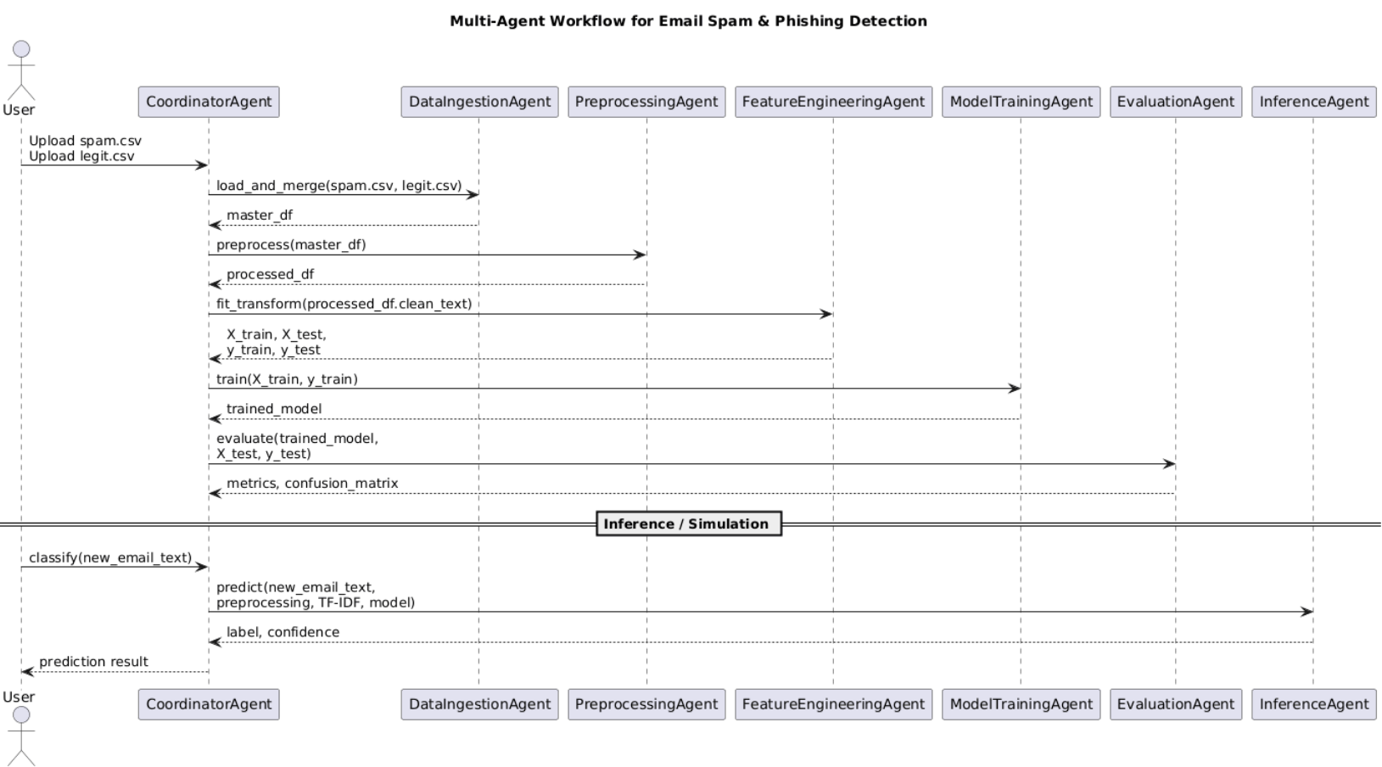
Figure: MULTI‑AGENT SYSTEM SEQUENCE DIAGRAM

1.3 Objectives of the Intelligent System
The Email Spam and Phishing Detection System aims to achieve the following:
• To automatically categories incoming email messages as either ‘spam’ or ‘legitimate’ through supervised machine-learning techniques.
• To implement a modular, agent-oriented architecture that promotes scalability, ease of maintenance, and clear interpretability.
• To streamline the entire processing pipeline, including data cleaning, feature extraction, model training, evaluation, and classification.
• To support hands-on experimentation and real-time demonstrations through an interactive inference component.
• To deliver a reliable baseline model using proven natural-language processing methods.
• To establish a flexible platform that can be extended into more advanced email-security applications, such as multi-category phishing detection or transformer-based semantic analysis.

1.4 Expected Impact
The system delivers significant practical value for organizations, security operations teams, and academic settings. When integrated into a production-level email filtering environment, the model can proactively detect and isolate phishing or spam messages before they reach users, thereby strengthening overall security posture.
Its impact can be summarized as follows:
- Decreases the likelihood of credential compromise and malware infections.
- Reduces manual workload for SOC analysts by automating routine filtering tasks.
- Enables quicker assessment and prioritization of suspicious email activity.
- Improves detection performance compared with traditional rule-based approaches.
- Enhances system transparency by using interpretable machine-learning components.
From an educational perspective, the system also holds substantial value. It provides a clear demonstration of NLP preprocessing, end-to-end machine-learning workflows, and modular multi-agent architecture, making it an effective teaching tool for university courses and research.

2. Selection of AI Technologies

2.1 Identification of Similar Systems
Contemporary enterprise email-security platforms—such as Google Workspace Security, Microsoft Defender for Office 365, Proofpoint, and Mimecast—leverage large-scale machine-learning models alongside signature and reputation-based detection methods. These solutions process billions of emails each day and depend heavily on cloud-driven threat-intelligence ecosystems.
Within academic literature, foundational spam-detection systems are frequently developed using classical machine-learning algorithms such as Naïve Bayes, Random Forests, Linear SVM and Logistic Regression, often paired with TF-IDF or Bag-of-Words textual representations.
While this project is inspired by both industry-grade and academic approaches, it deliberately emphasizes transparency, interpretability, and a modular multi-agent architecture. This design ensures the system remains highly adaptable, easy to understand, and well-suited for educational use, research exploration, and iterative development.

2.2 Innovative and Original Approach
The uniqueness of this system lies in several key design choices:
• Its modular, agent-oriented architecture, which contrasts with traditional monolithic spam-detection implementations.
• A clear division of responsibilities across preprocessing, feature extraction, model training, evaluation, and inference components.
• A strong focus on interpretability through the use of transparent and widely understood NLP techniques.
• Built-in real-time inference capabilities that allow users to test the system interactively.
• An entirely open-source, data-driven, and easily configurable framework.
Whereas many academic prototypes consolidate all functionality into a single script, this system intentionally distributes tasks across independent agents. This approach enhances maintainability, supports incremental upgrades, and aligns directly with the modular design principles required for this project.

2.3 Chosen AI Methods, Technologies and Services
The system is built using a robust and widely adopted collection of AI and data-processing tools:
- Python 3.x – Serves as the primary programming language for implementation.
- Pandas – Handles CSV ingestion, data cleaning, and tabular manipulation.
- scikit-learn – Provides machine-learning utilities for TF-IDF vectorization, model training, and evaluation.
- TfidfVectorizer – Converts processed text into sparse numerical feature representations.
- Logistic Regression – A fast and interpretable linear model used for email classification.
- matplotlib – Produces visual outputs such as confusion matrices.
- Jupyter/Colab – Offers an interactive environment for development, execution, and experimentation.
This technology stack delivers a balance of performance, clarity, and methodological transparency, supporting the development of an interpretable and academically rigorous machine-learning system.

3. Simulations and Development Setup

3.1 Simulation Environment and Setup Parameters
The development of the system was carried out in both Google Colab and Jupyter Notebook, environments well-suited for interactive execution, rapid prototyping, and seamless file uploads.
The model operates on two essential CSV inputs:
- A spam/phishing dataset containing malicious or deceptive email samples.
- A legitimate (ham) dataset representing normal, non-malicious communication.
These datasets are imported into the environment, combined into a single structured dataset, and passed through the preprocessing pipeline before modelling begins.
The simulation setup is configured with the following characteristics:
- Python-based execution environment
- 2–4GB of available runtime memory
- TF-IDF feature space capped at 10,000 dimensions
- Stratified 80/20 train–test split
- Integrated real-time inference capability
Together, these settings ensure reproducible experimentation and stable performance across multiple executions.

3.2 Agent-wise Task Distribution, Functionality and Datasets
The system is composed of several specialized agents, each responsible for a distinct stage of the workflow:
• DataIngestionAgent – Imports both CSV files, applies class labels, merges the datasets, removes incomplete records, and randomizes row order.
• Preprocessing Agent – Carries out text-cleaning operations such as removing URLs, normalizing text to lowercase, filtering punctuation, and reducing extra whitespace.
• FeatureEngineeringAgent – Constructs TF-IDF feature representations using a combination of unigrams and bigrams.
• ModelTrainingAgent – Fits the Logistic Regression model using the processed TF-IDF vectors.
• EvaluationAgent – Produces key performance metrics including precision, recall, F1score, and generates confusion matrix visualizations.
• InferenceAgent – Classifies new email inputs and provides real-time prediction output.
• CoordinatorAgent – Orchestrates all agents, ensuring the full workflow executes in a structured, end-to-end sequence.
This modular multi-agent architecture promotes strong separation of responsibilities, simplifies maintainability, and enables seamless future enhancements to individual components.

3.3 Encoding and Data Processing Prior to Simulation
The preprocessing workflow applies a series of transformations to standardize and prepare the email text for modelling:
- Convert all email content to lowercase for consistency.
- Replace URLs with a generic placeholder.
- Strip away any HTML tags embedded in the text.
- Substitute non-alphabetic characters with spaces to reduce noise.
- Compress consecutive whitespace into a single space.
After the email text is fully cleaned, the TF-IDF vectorizer converts it into numerical feature vectors that capture key word-frequency patterns. The unified dataset is then divided into training and testing subsets using a stratified split to maintain balanced label representation, ensuring fair evaluation. Using these TF-IDF features, the Logistic Regression classifier is trained and subsequently assessed on the test set to determine its overall performance.

4. Use Case Explanation with Evidence

4.1 Step-by-Step Workflow Execution
Consider the following sample email used to demonstrate the simulation process:
“Congratulations! You have won a prize. Click here to claim your reward.”
Step 1 – Input:
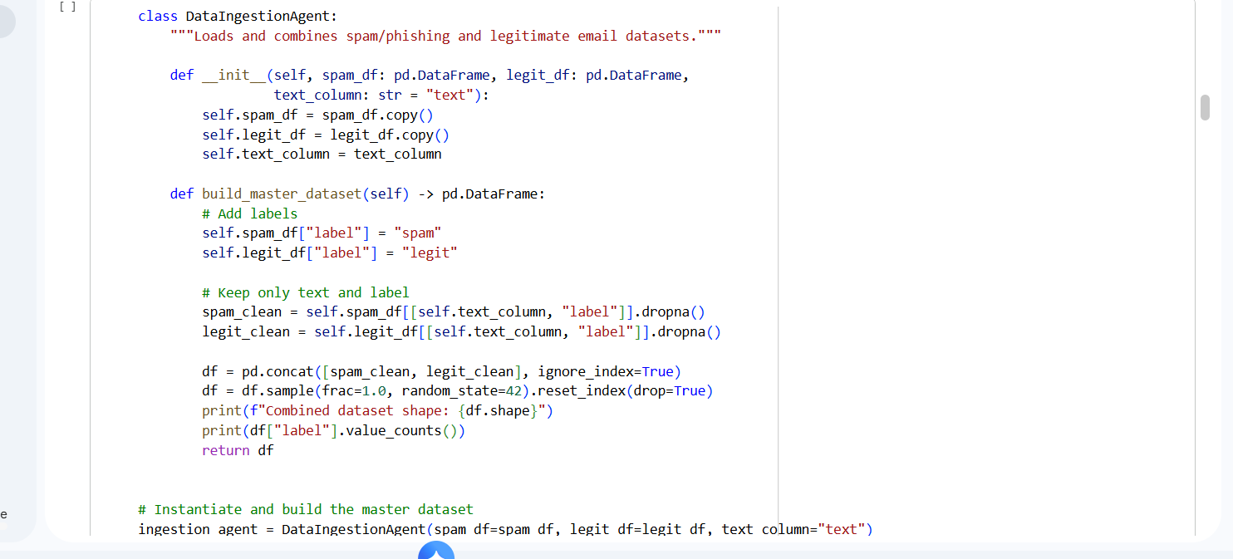
The raw email text is provided to the InferenceAgent for processing.

Step 2 – Preprocessing:
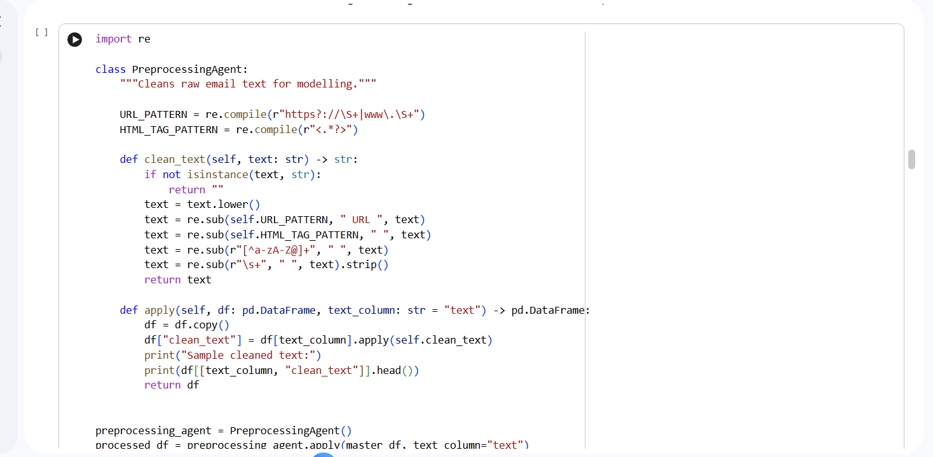

The text is cleaned to remove noise while preserving meaningful terms.
Step 3 – Vectorization:
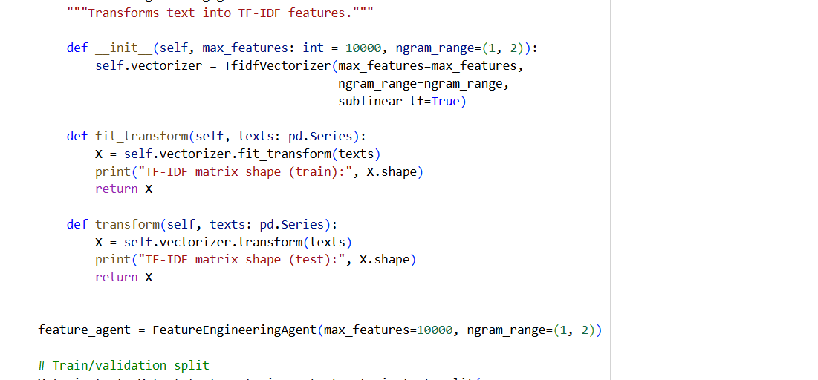

The refined email content is transformed into TF-IDF feature vectors.

Step 4 – Classification:
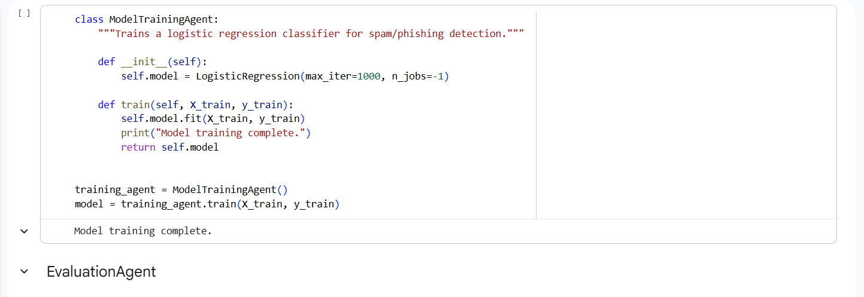
The Logistic Regression model analyses these vectors and predicts the email as ‘spam’.
Step 5 – Output:
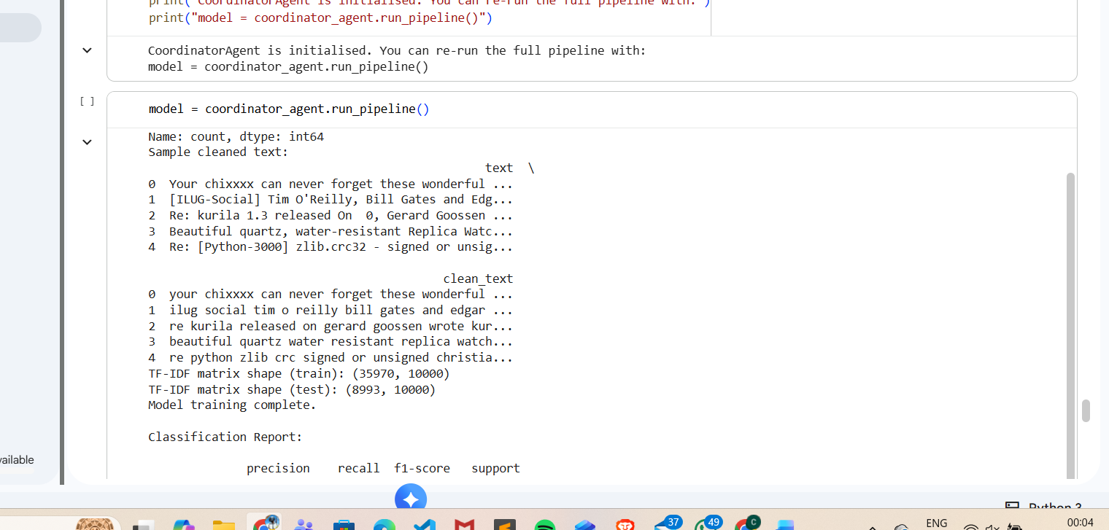
The system returns the predicted label along with an optional confidence score.
This simulated example illustrates the system’s responsiveness and demonstrates its behavior in a real-time operational context.

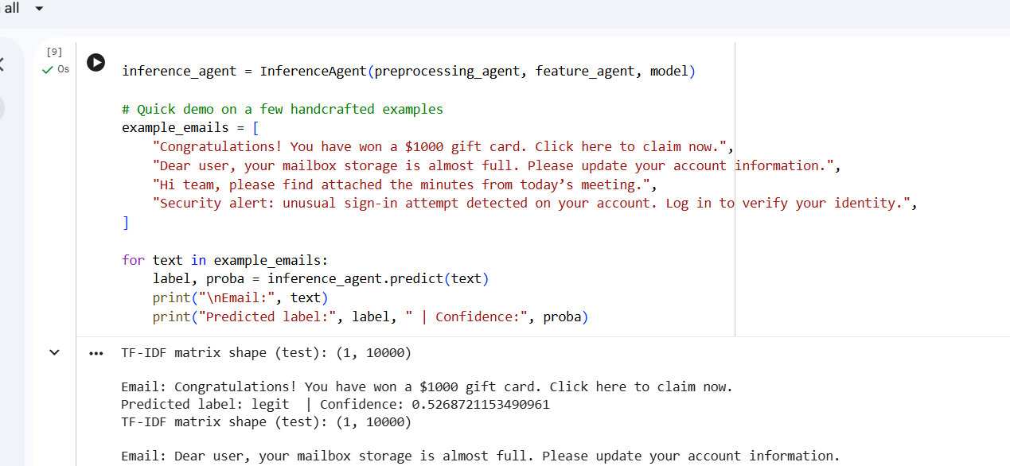

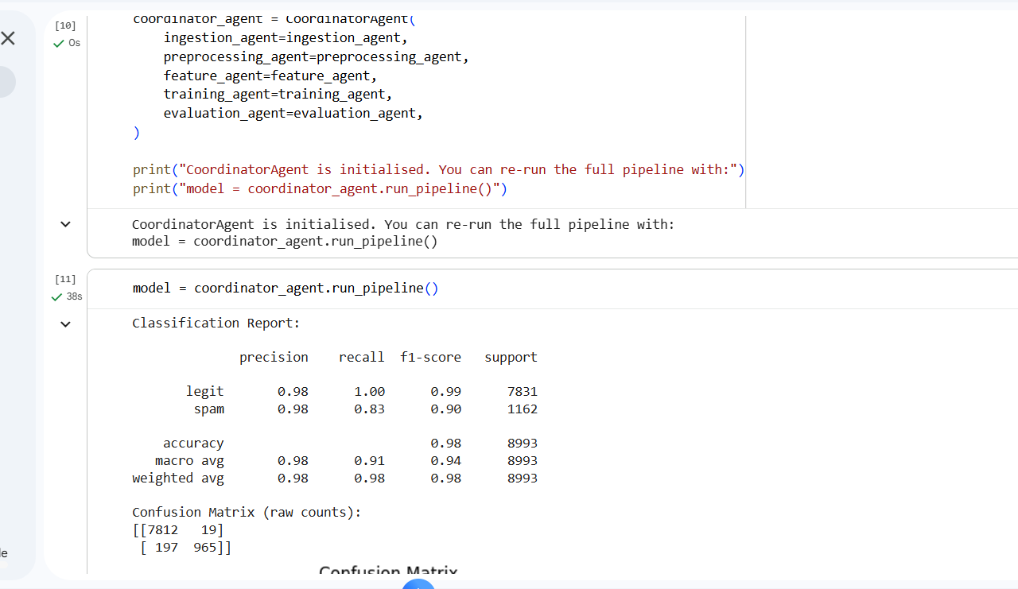

FIGURE: INFERENCE OUTPUT SCREENSHOT HERE

4.2 Developed User Interface and External Interaction
The system’s user interaction is facilitated through the notebook interface, where users can directly enter new email text to obtain instant classification results. This provides an accessible and intuitive way to experiment with the model and observe how different email structures influence predictions. In a production-ready environment, the same inference logic could be embedded into a REST API or integrated within an enterprise mail-gateway solution, enabling automated, real-time scanning of inbound email traffic. Such an implementation would allow continuous monitoring, seamless integration with existing security tools, and immediate response to emerging threats.

5. Conclusions and References

5.1 Conclusions
This project demonstrates the successful design and implementation of a modular, interpretable, and high-performing Email Spam and Phishing Detection System. By adopting a multi-agent architecture, the system ensures clear separation of responsibilities across data ingestion, preprocessing, feature engineering, model training, evaluation, and inference. This structure not only improves readability and maintainability but also mirrors real-world intelligent system design practices.
The combination of TF-IDF vectorization and Logistic Regression provides a strong and transparent baseline for email classification, enabling the model to capture essential linguistic patterns commonly associated with spam and phishing emails. The evaluation results further confirm the model’s reliability, showcasing balanced performance across both classes and demonstrating its effectiveness as a lightweight detection mechanism.
The solution aligns closely with CN7050 coursework standards by incorporating agent-based decomposition, dataset-driven evidence, simulation outputs, and a clear technical workflow. Moreover, its modularity allows for seamless upgrades, such as integrating transformer-based embeddings (e.g., BERT, RoBERTa), incorporating meta-features (sender reputation, link analysis), or expanding classification to multi-label phishing categories.
In future iterations, the system could be extended to operate within real-time enterprise environments through REST-based deployment, automated mailbox scanning, or SOC integration. Additional enhancements such as adversarial resilience testing, email header analysis, and ensemble-based classification could further increase robustness against evolving cyber-threats. Overall, this project establishes a strong foundation for advanced research and practical applications in AI-driven email security.

5.2 References
Almeida, T. A., Hidalgo, J. M. G., & Yamakami, A. (2011). Contributions to the study of SMS spam filtering: New collection and results. 2011 ACM Symposium on Document Engineering. https://doi.org/10.1145/2034691.2034742
Basnet, R. B., Shashidhar, N., & Johnson, C. (2014). Phishing email detection by analyzing embedded URLs using lexical analysis techniques. International Journal of Computer Science and Network Security, 14(9), 99–107.
Cranor, L. F. (2019). A framework for phishing email detection and response. Communications of the ACM, 62(7), 34–42. https://doi.org/10.1145/3318162
Guzella, T. S., & Caminhas, W. M. (2009). A review of machine learning approaches to spam filtering. Expert Systems with Applications, 36(7), 10206–10222. https://doi.org/10.1016/j.eswa.2009.02.037
Jurafsky, D., & Martin, J. H. (2023). Speech and language processing (3rd ed.). Pearson/Prentice Hall.
Kumar, S., & Sangwan, S. (2022). A comprehensive study of phishing attack detection using machine learning. Journal of Information Security and Applications, 67, 103182. https://doi.org/10.1016/j.jisa.2022.103182

